ECONOMICS 2004-06: SECTION 3: MACROECONOMICS STANDARD

3.1 MEASURING NATIONAL INCOME

Microeconomics vs. Macroeconomics
- Microeconomics deals with individual markets and with the actions of households and firms in those markets.
- Macroeconomics deals with the major groups of players in the economy, consumers, producers and govts.
- Prices: instead of looking at individual prices we look at the price level.
- Income: instead of looking at household income we look at National Income.

3.1.1 Circular flow of income and spending
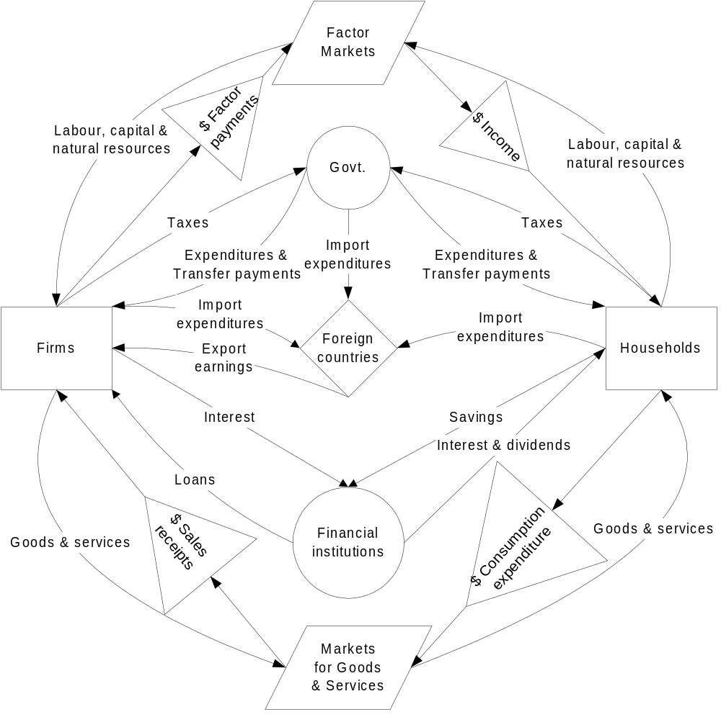

- Households own the factors of production: labour, capital and natural resources. They offer them to firms in return for wages, profit and rent.
- When consumers receive income:
- Leakage: they give some of it to government in the form of taxes
- Transfer payments: they receive subsidies from the government
- Leakage: they save some in financial institutions
- Injection: they receive interest on their savings
- Leakage: they import goods and services from foreign countries

- Firms use the factors of production to produce goods and services.
- In order to produce goods and services:
- Injection: firms borrow money from institutions and inject it back into the system in the form of investments
- Leakage: firms pay interest to financial institutions
- Leakage: firms must pay taxes to governments on their profits
- Transfer payments: firms receive subsidies from governments
- Leakage: firms import goods and services from foreign countries
- Injection: firms export goods and services to foreign countries.

- Government is the third major actor in the system.
- Government tax and spend:
- Leakage: taxation on households, firms and imports from foreign countries
- Injection: government expenditures on goods and services from firms and households
- Injection: government spending on state provided goods and services
- Transfer payments: usually in the form of subsidies to households and firms
- Leakage: imports of goods and services from foreign countries.

3.1.2 Methods of Measurement
- The total of all the goods and services made in any one year in a single country which go through a market place is referred to as the National Product.
- As someone must have earned money to produce those goods and services, it is also referred to as National Income.
- One of the most common measures of national income is Gross Domestic Product (GDP). If real GDP increases then it indicates that the economy is producing more output each year.
- There are three methods of calculating national income.

The expenditure method:
- This adds up all the spending in the economy: C + I + G + X - M.
- It is called Gross Domestic Product (GDP) at market prices and includes:
- C: Consumption
- I: Investment which includes:
- Planned investment in capital
- Unplanned increases in stocks or inventories
- G: Govt. spending on goods and services. Because they are often provided free of charge (no market value), they are valued at cost.
- X: Exports: the domestic economy receives the money
- M: Imports: these must be subtracted because it is spending on goods and services from outside the domestic economy.

The income method
- Adds up all the sources of income in the domestic economy.
- Transfer payments (pensions, unemployment and welfare benefits) are excluded: no good or service is produced for the income.
- Income includes:
- Wages and salaries
- Self-employed income
- Profits: divided into dividends given to shareholders and undistributed or earnings retained by the firm
- Rent which includes the cost of raw materials and intermediate inputs and imputed rent on any owner occupied housing
- Interest

The output method:
- Adds up the value added by a firm’s production:
- The value of the firm’s output minus the value of inputs
- Alternatively this method adds up the output of final goods and services.
- If $100 worth of goods and services has been produced (output method) this must have generated $100 worth of income (income method) for the various factors of production and will lead to $100 worth of spending (expenditure method).
- If spending by households is added up this will show the spending at market prices. But this does not truly reflect income earned by factors because of indirect (sales) taxes paid by firms to govt. and subsidies received by firms from govt. Therefore:

Market price - indirect taxes + subsidies = factor cost.

Personal Disposable Income
- Personal Disposable Income is obtained by:
- GNP = GDP at market prices + net property income from foreign economies
- GNP at factor cost = GNP at market prices - indirect taxes + subsidies
- Net National Product (NNP) = GNP at factor cost - depreciation
- where: NNP is sometimes referred to as Net National Income (NNI)

- Personal Income = NNP - retained earnings - business taxes + transfers
- where: retained earnings = undistributed profits

- Personal Disposable Income = Personal Income – personal income taxes.

3.1.3 Distinctions & Adjustments
- Gross Domestic Product (GDP): the value of final goods and services produced by factors within the domestic economy must be adjusted to exclude:
- Goods made in previous years and sold this year:
- If people do not buy everything produced in the year, firms end up with stocks of unsold goods called inventories which are included in investment.
- This method assumes the firms ‘bought’ the goods for themselves.
- Capital gains which are just a redistribution of benefits.

- Intermediate goods or semi-finished goods:
- Final goods already include the value of the intermediate good, and it would be double counting to include intermediate as well as final goods

- Investment includes:
- Circulating capital: inventories or stocks of raw materials, intermediate goods and final goods.
- Capital equipment, machinery and buildings, and residential housing
- Gross investment consists of:
- Net investment (new physical capital and stocks or inventories)
- Depreciation or capital consumption: repair and maintenance to existing stocks of capital or replacement of worn out capital.

Gross and Net
- Net Domestic Product (NDP) = GDP - depreciation. Because depreciation is an estimate, most economists prefer to work with GDP.

Nominal and Real
- Inflation may have increased values being added and we would like to distinguish between changes due to inflation and actual changes in the physical outputs.
- To do that we use a price index to deflate the production back to some base year period of prices, and we call it real national income, Y.

- If national income rises is this an indication of a rise in the standard of living?
- Inflation: can cause GDP to rise even if there is no extra production.
- To eliminate this problem GDP is adjusted for inflation:
- Real GDP = Nominal or current GDP/Price deflator
- Does the price deflator take into account the increase in quality of goods and services and the fall in the prices of goods such as videos and computers?

Total and Per Capita
- Standard of living: if the population has grown faster than real GDP, then output per person has actually fallen. To measure real per capita GDP we deflate GDP to put it into real terms, and then we divide it by the population.
- Population increases: cause GDP to rise but not necessarily per person:
- To adjust for this problem we divide by the population:
- Real Per Capita GDP = Real GDP/Population

3.2 INTRODUCTION TO DEVELOPMENT

3.2.1 Definitions of Economic Growth and Development
- Economic development occurs if there is a reduction in poverty, inequality, and unemployment. This will include increasing the access to and the means to obtain improved food, shelter, health and protection under law.
- If growth occurs with no improvement in living standard for most of the population, then economic development has not taken place.
- Trickle down theory (market economy): an early theory which assumed that economic growth, leading to greater prosperity, would diffuse from the rich to the poor raising overall living standards.
- Development plan (central planning): must include targets and policies for reducing poverty, inequality and unemployment.

- There are 144 developing economies (LDCs) in the world, of which 83 have fewer than 5 million people.
- LDCs tend to have low standards of living, and low GNP per capita.
- Low income countries receive $700 per capita, middle income countries receive from $700 to $8,000 per capita.
- They tend to have a high population growth rate.
- More than 50% of the population is involved in primary production.
- Primary goods are the most prominent exports.
- Mining tends to be dominated by Transnational Corporations (TNCs).
- Infrastructure, often built by colonial powers, is designed to move primary goods to the coast for shipment overseas.
- All sectors are characterised by low productivity and high unemployment.
- Capital equipment and technology is likely to have been imported.
- Processing and manufacturing for export is discouraged because MDCs tend to raise trade barriers against higher value added goods.
- Economic power is unequally distributed both internally and externally.
- Latin American and Asian countries tend to have more private enterprise, African countries tend to have greater state ownership of enterprises.

3.2.2 Measuring Growth
- The share of a sector or component of GDP such as manufacturing or agriculture is measured by the value added contributed by that sector.
- Value added: the addition to value of a product during a stage of production.
- Value added in the cotton textile industry: the value of the textiles when they leave the factory minus the value of raw cotton used in their manufacture.
- This is equal to payments to the factors of production: wages paid to labour plus profits, interest, depreciation of capital, and rents for buildings and land.

- If economic growth is 1%, it will take approximately 72 years for the value of the economy to double.
- If the growth rate is 10% it will only take 7.2 years for the economy to double.

3.2.3 Comparing Across Countries

Limitations of using GDP
- Per capita income still ignores the distribution of income: there could be a few rich people and large numbers of poor.
- Non-market sector: goods and services traded in a barter or parallel economy which are not reported as output or income. How do we include them?
- Future growth through capital goods: national income accounting does not distinguish between the production of consumption and capital goods:
- Producing consumption goods leads to more today but less tomorrow.
- Production of capital goods involves less consumption today but higher future growth and greater consumption in the future.

- Externalities: pollution and the cleanup of pollution or increased traffic congestion and the resulting increase in gas consumption can actually lead to a rise in GDP even though the quality of life may have been reduced.
- Quality of life: pollution regulations or more vacation time can lead to a fall in GDP but lead to an increase in the quality of life; how should we adjust?
- Govt. services: how do we value national defense or govt. medical services? We count them at cost which may be too high or too low an estimate.

National and Domestic
- Gross National Product (GNP) includes the value of final goods and services produced by factors owned by domestic households all over the world:
- GNP = GDP + Foreign investment income – investment income paid to foreigners
- For developing countries, GDP tends to exceed GNP: factor payments made to foreigners exceed factor payments received from foreigners
- For industrialized countries, GDP is smaller than GNP: factor payments received from foreign countries are larger than what is paid to foreigners.

Allowance for differences in purchasing power
- Purchasing power parity: rather than use a single currency to compare we convert to PPPs which measure the actual purchasing power of domestic income in terms of what it can buy within the country.
- Accounting systems are different amongst countries. Many LDCs cannot afford comprehensive systems and use a lot of guesswork or estimation to fill the gaps.
- Climate differences: some countries spend more on energy to heat or cool houses and offices.
- There may be considerable differences in the distribution of income, the size of the non-market sector, the balance between consumption and capital goods production and between production of consumer goods and weapons for war.

3.3 MACROECONOMIC MODELS

3.3.1 Aggregate Demand
- Aggregate Demand (AD) consists of C + I + G + X - M
- Internal expenditure or what is sometimes referred to as domestic absorption:
- C = Consumption is a function of income, and the slope of the consumption function is the MPC.
- I = Investment is a function of income and interest rates (usually referred to as the Marginal Efficiency of Investment or MEI)
- G = Government expenditures change slowly as such a high proportion of expenditures are legislated that govt. has very little discretion over budgets.

- External expenditure:
- X = Exports are a function of foreign and not domestic income.
- M = Imports are subtracted from AE and are very similar to consumption: they are a function of domestic income.

- (X - M) = Net Exports:
- As domestic income rises, people import more and net exports (X-M) fall.
- If world income rises, net exports (X-M) rise: X is a function of foreign income.
- If domestic prices rise, exports fall and imports rise so net exports fall.

- If domestic prices rise relative to foreign prices, net exports tend to decline:
- Exports decline because foreigners find domestic goods more expensive.
- Domestic households find foreign goods relatively cheaper and will tend to import more.

- Depreciation of the domestic currency means that it will buy less of foreign goods, net exports tend to rise:
- Foreigners will find domestic goods cheaper
- Households will find foreign goods more expensive. Leakages and Injections

- There are three leakages from the system: savings, taxes and imports.
- There are three injections: investment, government expenditures and exports:
- There does not have to be equality between each pair (I = S, G = T, X = M).
- But there does have to be equality between all three injections and all three leakages: (I + G + X) = (S + T + M) in equilibrium.

The Influence of Income on Consumption
- Consumption is the largest single category of domestic expenditure, accounting for over 50% of GDP, and including consumption of foreign goods (imports).
- Changes in consumption can be predicted by analysing changes in:
- Income and wealth
- Credit availability:
- Goods are divided into perishable (food), semi-durable (clothes) and durable (cars).
- The availability of credit will allow people to buy more expensive durable goods which means they are able to spend more than their current income. However, repayment of past debt will limit current consumption.

- Expectations: optimism leads to greater spending, this is why we measure Consumer Confidence.
- The age profile of the population: younger households spend to build up a household, middle age households start to save toward retirement.
- Price levels: rising prices reduce the value of money and may lead people to save more to rebuild real money balances.
- After tax income is divided between savings and consumption:
- If income taxes are 30%, then after tax income is 70% of national income
- If consumption is 80% of after tax income, it is 0.8 times 0.7 , or 56% of national income.

The Influence of Wealth on Consumption
- Savings depend on wealth and the position in the life cycle for the family.
- People want to smooth their consumption pattern over their lifetime:
- Only with a permanent change in income will people adjust their consumption.
- With a temporary decline in income, people maintain consumption levels according to their expected income by running down their savings

- People have a goal for their wealth and will keep adding assets to their portfolio:
- People keep adding to wealth until the income flow from that wealth will allow them to retire:
- If there is a temporary increase in income
- People save it and add it to wealth.
- Consumption increases only out of the income earned from that wealth.

- For example: if you receive an extra $10,000 worth of income, and you normally consume 80% of your income:
- We would expect you to consume $8,000 out of that extra income.
- Instead, you add the extra $10,000 to your wealth, and let us assume that those assets earn $1,000 at 10% interest
- You would consume only $800 or 80% of the income earned on your assets.

- If the level of wealth is below the target, households will save toward the goal. If the level of wealth is at the target, households no longer need to save.
- An unexpected rise in wealth will lead people to save less, and vice versa.
- If prices rise in the economy, the purchasing power of wealth declines:
- Households will attempt to save more to add back the wealth that has been lost, this means that consumption will fall.

Aggregate Demand
- Income effect: the AD curve is downward sloping because as prices rise, real income falls and people have less to spend.
- Price induced changes in any of C, I , G, X or M leads to movements along the AD curve.

- Substitution effect: when the price level rises in the economy there are no substitutes to switch to as in microeconomics. There are three possibilities:
- Real balance effect: as prices rise, the real value of wealth declines, people tend to build the wealth back again by saving more and consuming less.
- Net export effect: as domestic prices rise relative to foreign prices, exports become expensive and imports cheaper: thus exports fall and imports rise.
- Interest rate effect: people may try to borrow to maintain their spending, interest rates rise which discourages durables consumption and investment.

- Whenever C, I, G, X and M change, the aggregate demand curve shifts in and out
- Note these are not price induced changes, if they were they would lead to movements along the curve rather than to shifts.

3.3.2 Aggregate Supply

Components of AS
- These include the labour force, the amount of capital goods and the available natural resources.
- As the prices of these factors of production rise, the SRAS curve slowly shifts in. It simply costs more to produce the same output.

Shifts in SRAS
- If the factors of production become more productive, the SRAS curve shifts out.
- For most countries, there is a slow but steady increase in productivity each year:
- Part of it comes from new investment in capital equipment, and part from education and training of the work force.
- This increase in productivity causes the SRAS curve to shift steadily outward, although at a slow rate
- Technology: as technological progress occurs, the SRAS curve shifts out.

Slope of the SRAS
- The aggregate supply slopes upward as the full employment point is reached:
- Not because factor prices are rising: along the SRAS curve it is assumed that factor prices stay the same.
- Diminishing returns: near full employment some factors, particularly capital, are fixed in supply, and costs rise because more of a variable factor is added to a fixed factor.
- Resource Bottlenecks: as full employment is approached even some variable inputs are in short supply and this slows the production process raising costs.
- Declining productivity:
- As firms hire more labour and capital, the people and machines left to hire are less skilled or less efficient (the best have already been hired as we approach full employment)
- Productivity falls, unit costs rise and firms raise prices to cover increased costs of production.

Regions of the Aggregate Supply curve
- The actual shapes of the SRAS and LRAS are crucial to the effectiveness of fiscal and monetary policy:
- Extreme Keynesians believe the SRAS to be flat until full employment at which point it is vertical.
- Extreme neoclassicals believe the SRAS and LRAS are vertical at the full employment point.
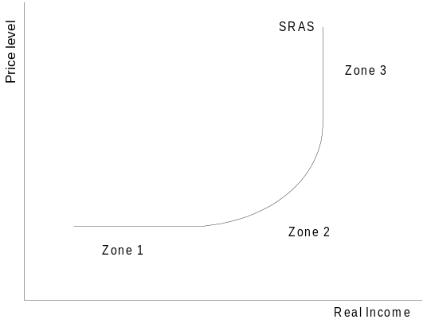

- A moderate, consensus view is that there are two curves:
- A vertical LRAS: where inflation depends on people’s expectations (zone 3 of the SRAS is often interpreted as the LRAS):
- If people correctly anticipate inflation, expected inflation will equal actual
- Unemployment only departs from the natural rate when inflation is not anticipated.
- The natural rate of unemployment will change only if there are changes in frictional, structural or seasonal unemployment.

- An SRAS which is fairly flat (zone 1) until the GDP starts to approach the natural rate of unemployment at which point it slopes up (zone 2). In zone 1:
- The expected rate of inflation is constant
- The natural rate of unemployment is constant.

3.3.3 Equilibrium level of national income
- Suppose the AD curve shifted out to the right because one or more of the components either increased (C, I, G, X) or decreased (M).
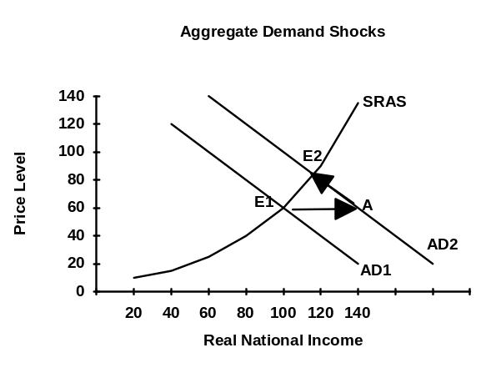

- In the figure we move from equilibrium at E1 to point A:
- AD > SRAS: inventories must be falling and businesses hire labour.
- Increased production leads to an increase in Y: we move along the SRAS curve from E1 to E2.
- However, as businesses hire more labour, they find that they are less skilled, productivity falls, unit costs rise, and firms are forced to raise prices.
- The increased price level leads to price induced changes in AD:
- Consumption falls, exports fall and imports rise
- We move back along AD from point A to point E2, a point of short run equilibrium
- AD = SRAS: inventories are neither rising nor falling.

At Y₁ where AD1 = SRAS₁
- 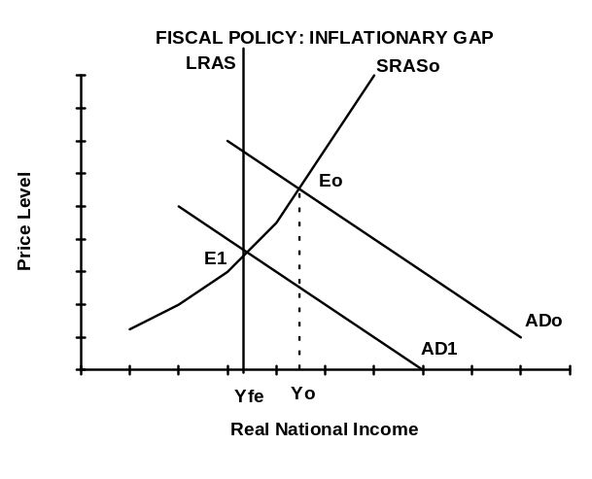At Y1, income is above the full employment point, this can only occur if labour works overtime:
- The average workweek expands from 40 hours per week to as high as 55 hours per week.
- Labour shortages will emerge in some industries and among skilled workers.
- High profits for firms and unusually large demand for labour exerts upward pressure on wages.
- Capital is operated beyond the safe capacity:
- Most firms experience a 15% depreciation rate each year, which means that only 85% of the machines are running to allow repairs and replacement of old machines.
- Capital can be kept going without regular maintenance, but it damages the machinery and raises the costs of capital, this causes SRAS to shift up.

- As factor costs rise, the upward pressure on wages means there is pressure for wages to rise faster than productivity is rising.
- The SRAS will shift left because of upward pressure from the labour market.

- Short run equilibrium is associated with the following criteria:
- AD = SRAS; leakages = injections; and inventories are unchanging.
- Long run equilibrium requires all the above plus:
- %∆wages = %∆productivity; or real wages are unchanging.

At Y_{fe}
- This is the full employment level of income, we are in long run equilibrium:
- Factor costs are neither rising nor falling: wages are rising at the same rate as productivity is growing.

- This is why the vertical line above Y_{fe} is referred to as the long run aggregate supply curve (LRAS).

At Yo
- Income is less than full employment income:
- Unemployment means there should be downward pressure on wages, however, unions and workers resist any attempt to lower wages.

- There is unusually low demand for labour:
- There will be labour surpluses and firms will resist upward pressure on wages.
- Wages will increase more slowly than productivity: unit labour costs will be falling.
- The SRAS will be shifting to the right: %∆Q/L > %∆wages.
- Eventually we will reach long run equilibrium at point E3.

Wages are Sticky Downward
- Unit labour costs fall much more slowly in a recession than they rise in a boom:
- There is great resistance to wages being cut.
- Even in quite severe recessions when prices are stable, wages may continue to rise, although the rate of increase tends to be lower than the increase in productivity.

Long Run Equilibrium
- 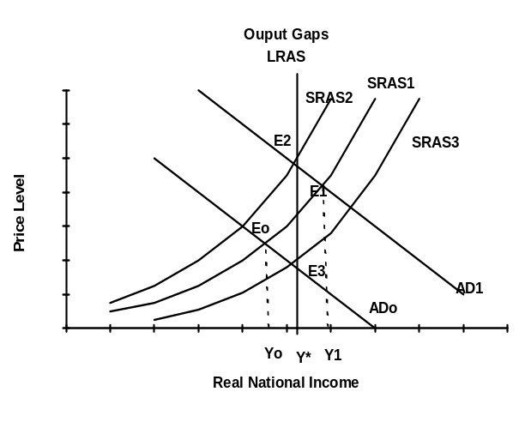Potential (full employment) income is constant and is shown by a vertical line, often called the Long Run Aggregate Supply curve (LRAS).

- At Eo we are in short run equilibrium with ADo = SRAS₁, equilibrium income is below potential income and we get a recessionary gap (negative output gap).

- At E₁, equilibrium is above potential or full employment income and we get an inflationary gap (positive output gap).

3.3.4 Business Cycles
- In Economic Development we will examine how growth can be increased through various policies designed to increase productivity:
- The economy as a whole moves in an upward direction called the long term trend or growth pattern which results from:
- Population growth
- Increases in productivity or output per person which come from: investment in capital, human capital, and R & D leading to technological breakthroughs.

- In Macroeconomics we deal with cycles and policies to counteract cycles. During any ten year period there is a cycle in the economy which appears to be related to the replacement of worn out capital equipment.
- Seasonal cycles are related to the primary sector: agriculture, forestry, fishing.
- With industrialization, a new manufacturing or industrial cycle appeared:
- The two most powerful cycles appear to be a 3 year cycle and a 10 year cycle. Because they are not matched, it means that the combination of the two leads to different patterns each decade.

- Typically at the end of a decade, industrialized countries tend to enter a serious recession which ends in a trough in the first year or two of the new decade, followed by an economic recovery.
- Recovery proceeds to roughly the middle of the decade at which point there is typically a mini-recession with a small peak and a trough.
- A new recovery period begins and countries enter a boom toward the end of the decade
- Once the economy peaks, a new recession follows.

- The cycles are not exact, and sometimes the mini-recession in the middle of the decade is deeper than the recession at the end of the decade.
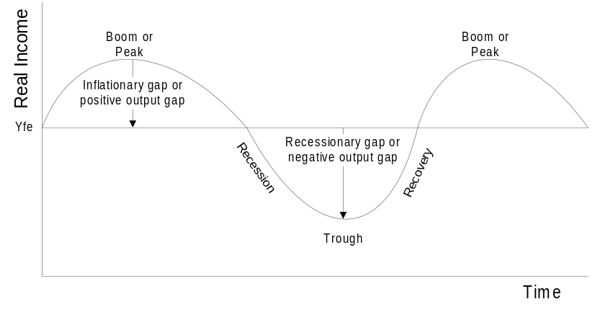

Boom Times
- During a boom the economy is operating at or beyond full capacity. There is a shortage of skilled people and raw materials. It is a period of excess demand.
- Prices rise faster than costs, profits are rising and investors are optimistic.

- The boom can turn into a slump if people decide they do not need to replace capital equipment because this leads to a fall in spending.

Capital Utilization Rate
- Rather than calling capital unemployed, we reverse the definition and look at the capacity utilization rate.
- Typically 15% of capital is being repaired or replaced and the average utilization rate is around 85%.
- During boom times the capacity utilization rate rises to as high as 92%.
- The rate of replacement of capital is slower than the demand for services from capital equipment.
- But there is a price for running capital so hard: maintenance schedules are not maintained and the capital wears out at a faster rate.
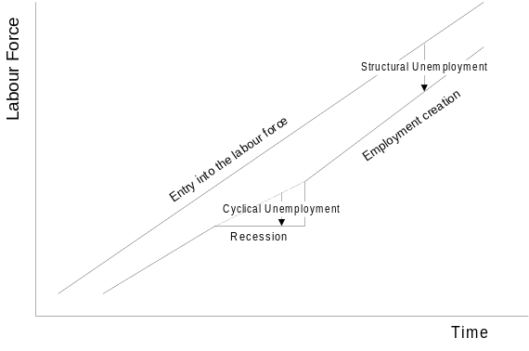

Recessions
- During a downturn, the job creation rate is typically slower than the number of people entering the job market looking for work:
- If there are people looking for work who cannot find it, they are defined as unemployed.
- As the economy starts to recover, the job creation rate speeds up and the unemployment rate falls particularly for skilled people. For the hard core unemployed, there may be very little change.

Trough
- A trough is associated with high unemployment of labour and unused productive capacity (unemployed capital).
- Unemployment rises not because people are laid off, but because the job creation rate is slower than the number of people entering the job market.
- Capacity utilization rates for capital may drop as low as 70%, this means that machines do not need to be replaced: when a machine wears out, you simply replace it with an existing machine which has been shut down.
- Business profits are low, and investors are pessimistic.

- A trough cannot last long because capital equipment wears out and both households and businesses start to replace it.
- Spending picks up and we enter a recovery.
- As sales and profits pick up, investors become more optimistic.

Depression
- If the recession is particularly deep and long lasting, it is called a depression.
- Typically a depression results when there is a financial panic during a recession.
- Better knowledge about the economy, stronger economic policies and the steady growth resulting from industrialization and technological breakthroughs appear to have prevented serious depressions in most western economies since 1930.

3.3.5 Output Gaps
- The output gap: a measure of the difference between actual and potential GDP.
- If the gap is negative: (Y – Y_{fe}) < 0, we refer to it as a recessionary gap.
- If the gap is positive: (Y – Y_{fe}) > 0, it means that we have gone beyond full employment and we are in an inflationary gap.
- It is possible to go beyond full employment by running more shifts in factories, using machines beyond their normal capacity utilization rate, and by paying workers more per hour to work more hours.

3.4 DEMAND-SIDE AND SUPPLY-SIDE POLICIES

3.4.1 Demand-side policies

Fiscal Policy
- Fiscal Policy is a tool of stabilization or demand management policy, and is used to remove recessionary and inflationary gaps by altering G and T.

- The budget balance, G – T, is the difference between expenditures and revenue:
- If they are equal, the govt. has a balanced budget.
- If revenue or receipts are greater than expenditures we have a budget surplus and if expenditures exceed receipts we have a budget deficit.
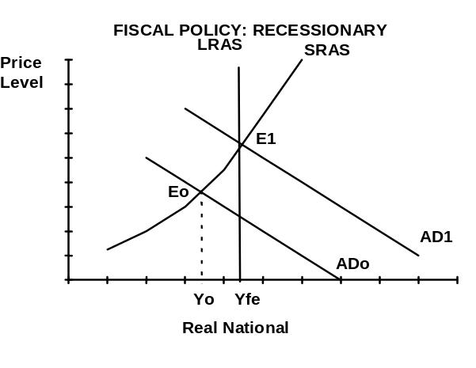
- If expenditures (G) are increased without a matching increase in T, it must be deficit financed meaning the govt. must borrow money.

- A recessionary gap can be removed by cutting T or increasing G which causes the AD to shift right.
- Alternatively the govt. could do nothing:
- Wages will fall, although very slowly, leading to a rightward shift in SRAS.
- Cyclical recovery: there may be cyclical forces in the economy that increase AD.
- There is a tendency for productivity, Q/L, to increase steadily over time leading to a rightward shift of the SRAS.

Monetary Policy
- In most countries the Central Bank (CB) is govt. owned and operated.
- Govts use the central bank to carry out monetary policy.
- The central bank is the lender of last resort: it stands ready to back any of the chartered banks if there are emergencies such as a run on the bank.
- It looks after govt. accounts and often buys govt. bonds, particularly if the bond market needs to be supported.

- Central banks are also usually responsible for the money supply.
- If the Central Bank (CB) buys a bond from the public, the public receives the cash in the form of a cheque from the CB and the CB receives the bond.
- Money is created through deposit creation rather than printing currency.

- Central banks are often responsible for bond and money markets.
- Bond markets refer to markets where debt instruments which mature in one year or more are traded.
- Money markets: where debt instruments maturing within one year are traded.
- In most countries the most common form of money market instrument is the treasury bill issued by a govt.

Demand for Money
- Households hold wealth in many forms: cash, bonds, stocks, real estate or in businesses. We assume that people hold only money or bonds.
- Wealth held in the form of money is called the demand for money.
- Once we know the demand for money, we also know the demand for bonds.
- The opportunity cost of holding money is the interest foregone on the bond that could have been purchased instead.
- As GDP rises in the economy, people will spend more because consumption rises, therefore the transactions balances will also rise.

Commercial Banks
- Commercial or chartered banks hold deposits for their customers and permit certain deposits to be transferred by cheque from one account to another.
- They make loans to households and firms and buy govt. securities.

- With credit granting systems like Visa, banks form a group to spread the risk.
- Bank deposits are a medium of exchange only because they can be transferred through the use of a cheque.
- Banks offer a safe place to store money and to earn a guaranteed return, commercial bank liabilities are the deposits owed to the depositors.
- Banks attract deposits by offering a rate of interest and by providing services for a small fee such as clearing cheques and providing regular monthly statements.
- Commercial bank assets are:
- The securities it buys which pay interest and dividends
- The loans it makes to its customers.
- Banks expect that the loan will be repaid, and that they will make enough money on the interest to pay for the paperwork and the risk of non-payment.

- Commercial banks tend to borrow short term from their depositors and lend long term to people and businesses that need loans. Banks can suffer if interest rates increase sharply in the short term.
- Part of the job of the CB is to ensure that interest rates move smoothly and slowly and the range over which rates fluctuate is fairly narrow.

Open Market Operations
- The most important tool for controlling the money supply and interest rates is the purchase and sale of bonds by the central bank (CB), referred to as open market operations.
- When the CB buys a bond from the public, the person selling the bond receives a cheque from the CB which is then deposited in a commercial bank.
- The bank sends the cheque to the CB which then increases the deposits of the commercial bank. Thus new money is injected into the system leading to a multiple expansion of deposits through the relending chain.

- When the CB sells a bond to the public, it receives a cheque from the person and sends it to the commercial bank for payment.
- The commercial bank sends the money to the CB and there is a contraction of the money supply through the relending chain operating backwards.
- Rather than calling in loans which can lead to bankruptcy, the commercial bank typically does not make any new loans until its reserves have recovered.

- When the CB sells bonds in the market, there are two effects:
- The reserve effect is that money now leaves the system and is put in the CB leading to a contraction of the money supply.
- At the same time, when the CB sells bonds, the price of bonds falls and interest rates rise leading to a contraction of investment and the AD curve.

- In reverse, when the CB buys bonds:
- The money enters the system leading to expansion through the relending system
- At the same time the price of bonds rise, interest rates fall and investment increases leading to an expansion of the AD curve.

Closing an Inflationary Gap: Fiscal Policy
- An inflationary gap can be removed by increasing T or cutting G which causes AD to shift left.
- Alternatively if the govt. chose to do nothing:
- Cyclical downturn: there may be cyclical forces in the economy that reduce AD.
- Or wages start to rise, shifting the SRAS in to the left leading to inflation.
- The value of money transactions rises, people sell bonds to obtain more money.
- Bond prices fall, interest rates rise, there is a price induced fall in investment.
- The fall in real expenditure leads to a movement back along the AD curve.

- Thus inflationary gaps are self correcting as long as the money supply is not increased, but the process is frustrated if the money supply is increased.
- With inflation of 15%, if the money supply increases 15%, people do not sell bonds to obtain cash, interest rates do not rise to choke off real expenditure.

Closing an Inflationary Gap: Monetary Policy
- Monetary policy could close the gap more quickly by decreasing the money supply, leading to a rise in interest rates, a fall in investment: AD shifts left.
- If the central bank wants to raise interest rates:
- They will sell bonds, the money supply will contract
- There will be an excess demand for money
- Households will sell bonds, and the price of bonds will fall
- This leads to an increase in interest rates in the market

Closing a Recessionary Gap: Monetary Policy
- If wages fall, SRAS would shift out, prices would fall and income rise.
- The value of money transactions falls, people buy bonds with the excess money.
- Bond prices rise, interest rates fall: there is a price induced rise in investment.
- The rise in real expenditure leads to a movement along the AD curve.

- As wages are sticky down, however, the SRAS shifts slowly to the right, and the fall in prices and the monetary adjustment mechanism operates very slowly.
- Monetary policy could close the gap more quickly by increasing the money supply, interest rates fall, investment rises and AD shifts out.
- If the central bank wants to reduce interest rates:
- They will buy bonds, the money supply increases
- People will buy bonds with the excess and the price of bonds will rise
- Interest rates will fall, and there is less incentive to hold bonds and eventually there will no longer be an excess demand for bonds.

Automatic Stabilizers (a type of autonomous fiscal policy)
- AD is constantly changing as a result of shifts in I, C, X and M. As recessionary and inflationary gaps appear they lead to changes in wage rates and shifts in the SRAS.
- This makes it difficult to identify when there is a recessionary or inflationary gap.
- In most western economies, there are built in stabilizers which tend to offset the fluctuations in AD:
- G tends to be very stable, the tax rate tends to be very stable, and govt. transfer payments for such things as pensions tend to be stable.
- However, transfer payments for welfare or to the unemployed tend to increase in recessions, thus automatically increasing G.
- Tax revenues equal the tax rate times income: (T = t*Y)
- If income rises as it does during inflationary gaps, tax revenues rise because both Y is rising and t is rising as people are pushed into higher tax brackets.
- As income falls during recessionary gaps, tax revenues fall.

- Taxes reduce the marginal propensity to consume:
- Even if the MPC is 80%, if taxes take away 50% of income, then effectively the MPC is only 40% out of national income.

- Short term fluctuations are dampened by the automatic stabilizers even when it is difficult to recognize when gaps appear and to apply policy.
- Automatic stabilizers impose fiscal drag during recoveries:
- As the economy recovers G falls and T rises which slows recovery.

3.4.2 Supply Side Policies
- Because of dissatisfaction with demand management policies, policy makers have turned to permanently reducing structural unemployment so when cycles occur, the impacts are less severe:
- If unemployment at the peak of the cycles is 7%, and if it rises to 12% to 13% at the bottom of the cycle, many people will suffer during downturns.
- If the natural rate of unemployment could be reduced to 2% at the peak of the cycle, then unemployment may not rise to more than 4% at the bottom.

- Supply side policies attempt to shift the LRAS to the right far enough to reduce inflationary pressures:
- By focussing on incentives:
- Taxes and subsidies are reduced to encourage work, risk taking and investment
- Unemployment benefits are reduced, raising the opportunity cost of not working.

- By increasing productivity of labour (Q/L rises):
- Education and training will increase productivity.
- Investment in capital will increase the K/L ratio.

- By increasing the productivity of capital (Q/K rises): through tax deductions for R&D: firms are motivated to find ways to increase capital productivity.

- By reducing the costs of inputs:
- Eliminating or reducing the minimum wage and the strength of unions.
- Lowering interest rates and thus lowering the rental price of capital.
- Providing incentives to find cheaper sources of raw materials.

- By reducing the power of big companies through anti-monopoly regulation.

European - Japanese approach:
- By assisting labour to move from sunset to sunrise industries, structural unemployment can be eliminated.
- In Sweden, when workers lose jobs in sunset industries:
- They have a choice of training for jobs in sunrise industries,
- The govt. pays for the full wages of the worker during the retraining, which usually lasts from 6 months to 2 years,
- The firm guarantees to hire the worker for a minimum of five years.

- In Japan, when firms close down a sunset division:
- The firm approaches the govt. and asks for training assistance for redundant workers in a new or existing sunrise division.
- The govt. pays the full wages during the training period, and the firm guarantees lifetime employment.

- In Germany students in high school try out careers in sunrise industries to reduce the numbers of students graduating in a redundant career,
- About 60% of high school students in Germany participate in a work coop program where they work from 1 to 5 afternoons a week in a firm or occupation they are interested in entering.
- Students are allowed to change once a year, and employers are permitted to ask students to leave if they have problems.
- Because students are exposed only to jobs and careers where there are openings, training for sunset industries is avoided.
- Because both students and firms have a chance to assess each other, by the end of high school firms are happy to hire students and students are happy to go to work in familiar firms.

US Approach
- The US govt. is reluctant to become involved in directing people into training and careers and has depended on tax cuts to bring about supply side changes.
- Reducing taxes will increase supplies of labour and capital:
- Lower taxes would increase the return on investment (ROI) and provide an incentive to invest in capital, thus increasing K/L.
- Lower taxes would also increase the return on research and development (R&D), leading to investment in even more productive capital.
- People who were already employed would work harder if they could keep more income after taxes, and those who were unemployed would be brought into the work force by the boost in income.

- Tax revenue would remain constant, even though tax rates had been cut:
- The increases in productive capacity (capital) and in productivity (labour) would shift LRAS to the right increasing the taxes collected.

- However, cuts in taxes can lead to an increase in C, causing a rightward shift in AD. During the Reagan administration this policy was pursued:
- In the short run, AD shifted to the right, opening up an inflationary gap.
- The supply side shifts of LRAS were not large enough and quick enough to counteract the aggregate demand effects.
- Incomes rose, but not by enough to restore tax revenues back to what they were: the result was bad deficits for the US govt.

- The supply side effects have been harder to find:
- They were dissipated throughout the economy.
- They did take place but over a longer period of perhaps 10 years or more.
- However, the reforms had a major effect on improving the functioning of the US economy, and reducing the natural rate of unemployment.
- They also appear to have led to disinflation: a slowing down in the rate of inflation. (Deflation is where prices actually fall).

3.4.3 Strengths & weaknesses of these policies

Problems with Fiscal Policy
- Fiscal policies attempt to reduce the suffering encountered in a market system by providing assistance to the less fortunate. The benefits are the counter-cyclical effects of automatic stabilizers, but the costs include:
- Disincentive to work: welfare and unemployment assistance has encouraged people supported by the govt. not to be productive by imposing a "tax" in the form of a loss of social assistance for those who go and work. This reduces the motivation to look for a job, and shifts the LRAS to the left.
- Increased taxes: the steady increase in taxes for social security have increased business costs, this has shifted the LRAS to the left.
- More regulation: greater regulation of industry protects firms from competition and leads to inefficiency which shifts the LRAS to the left.
- Substitution of capital for labour: there has been greater social regulation such as labour protection laws which have substantially increased the costs of hiring employees leading to the substitution of capital for labour which increases the natural rate of unemployment (shifting the LRAS to the left).
- Underground economy: higher tax rates have led to disincentive problems and to a significant proportion of economic activity going underground.

Lags
- Discretionary policy often runs into problems with lags:
- Recognition lag: it takes some time before a gap is recognized.
- Legislative lag: it takes time to decide what to do and if it requires a change in taxes or borrowing, it takes time to get approval from parliament.
- Implementation lag: it takes more time to put the policy into effect.

- The result is that stabilization policy or demand management policy has often done more to encourage fluctuations than to remove them.

Reversibility
- Another problem is that policies put into effect may be very difficult to reverse:
- If there were a recessionary gap, the govt. may decide to cut corporate taxes:
- After the usual lag, businesses start to increase investment.
- By the time the investment shifts out the AD curve, the economy may already have recovered and the shift in AD may open an inflationary gap.
- The problem then becomes one of trying to reverse the policy. It is extremely unpopular to raise taxes when businesses have become used to lower taxes.

- To overcome this problem it has been suggested that policies be made short run:
- The govt. announces that the tax cuts will only last for two years.
- This may help with investment, but many consumers will simply absorb the increased income into savings as a result of the wealth effect.

Financing Government Expenditures
- When govts. attempt to increase G, they must finance it somehow:
- They can raise taxes by the same amount as G, but this would lead to a fall in consumption and investment.
- They can borrow the money, but this leads to a rise in interest rates and a fall in investment:
- The demand for money shifts out, but the supply of loanable funds does not change so interest rates rise.
- This is called the “crowding out” effect because private businesses wanting to borrow money now find they have to pay more to borrow and cut investment.
- They can expand the money supply (govt. borrows from the central bank equivalent to printing money) and use the money to finance the increase in G, but this leads to inflation.

- The attempt to use fiscal policy to fine tune the economy is no longer accepted as a valid stabilization tool. Only where there are large persistent gaps, particularly gaps associated with recessions or depressions, is it generally agreed that fiscal policy does have role to play in restoring the economy to full employment.

Problems with Monetary Policy
- In the long run, because the LRAS is vertical above the full employment income level, the major impact of monetary policy will be on the price level.
- In boom times, the SRAS curve is very steep (zone 3):
- Shifts in the AD curve translate into large changes in the price level and little change in income.
- At less than full employment (zone 2) demand-side policy can affect both price and income in the short run.

- Rational expectations: people do not form expectations of future inflation based on the past; they tend to look ahead and make an estimate based on information they have available at that moment.

- Expectations can alter the speed at which adjustment takes place. A change in the expected rate of inflation will change aggregate demand:
- If inflation is expected to rise, consumers will increase current buying,
- If inflation is expected to fall, expenditures may be delayed.

- If the money supply is increased, and the AD curve shifts out to the right, workers anticipate that increasing the money supply will lead to higher prices and they will demand higher wages right away:
- The general expectation of an x percent inflation creates pressures for wages to rise by x percent and hence for unit costs and the SRAS curve to shift in by x percent.
- As AD shifts to the right, the SRAS shifts to the left.

- Rational expectations means that workers cannot be fooled, there is no “money illusion”.
- Workers know that real wages remain unchanged, and real income stays the same.
- Govt. will be unable to reduce unemployment below the natural rate even in the short run.

- While it is unlikely that the effects are completely offset, expectations are yet another reason why monetary policy may not be very effective.

The Transmission Mechanism
- Fiscal policy operates directly on AD through changes in G and T.
- Monetary policy operates through adjustments in the money supply which then lead to changes in interest rates and investment before impacting on AD. Problems with this transmission mechanism during depressions can make monetary policy useless:
- Monetary expansion fails because Banks hold excess reserves rather than lend money.
- Interest rates may not fall because people may hold money rather than invest in bonds (liquidity trap)
- Firms may be afraid to invest: the MEI curve is vertical, large changes in interest rates lead to only small changes in investment.

Lags in Implementing Monetary Policy
- The monetary transmission mechanism takes varying lengths of time from 18 months to 3 years. While there is still a recognition lag, there is no need for a legislative lag as the govt. does not have to go to parliament to get permission to change the money supply.
- There is still an implementation lag.
- Open market operations lead only slowly to changes in the money supply and interest rates.
- It takes time in companies to adjust investment plans in response to changes in interest rates.
- It then takes time for investment to be put in place and for the multiplier respending chain to lead to changes in national income: Economists estimate it takes 18 months on average for half the effects to be felt in the economy.

- Lags are long and unpredictable increasing the risk that using monetary policy could lead to destabilizing effects.
- The poor record of monetary policy as a short term stabilizer has led to the introduction of a monetary rule approach where the money supply would only be increased by a set amount.
- Some countries chose the rate as equal to the population growth rate plus the growth rate in productivity.
- Experience since then shows that there have been quite sudden shifts in the liquidity preference function, also known as the demand for money, which has made the monetary rule approach less stable than had been hoped.

- Most economists now believe that fiscal policy must be used to restore the economy to full employment during a serious recession or depression:
- The labour market experiences sticky wages which means wages fall too slowly
- Weaknesses in the monetary transmission mechanism plus lags mean that monetary policy is unpredictable.

3.5 UNEMPLOYMENT & Inflation

3.5.1 Unemployment

Policy Goal: Full Employment
- We assume that output and employment are closely related because output can only increase if employment increases.
- In a recessionary gap (negative output gap), there is a loss of production as a result of the unemployment: we can never retrieve that production.
- The labour force is often defined as those people between the ages of 15 and 65 who are either working or actively seeking work if they are not employed.
- Only unemployed people who are registered as unemployed will appear in national statistics.
- In MDCs there is a strong incentive to register because of unemployment benefits. This is not true in LDCs which means their unemployment statistics are less accurate.
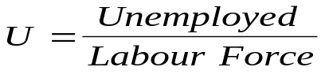
- The unemployment rate is defined as:

- Full employment: there is no output gap, we are at potential income. There are no people unemployed for cyclical reasons, but unemployment occurs:
- Search (or frictional): those who are in transition, they have finished studying and are entering the work force for the first time, or moving between jobs.
- Structural: those who have the wrong skills or are in the wrong location.
- There may be job openings but there is a mismatch between the skills required and the skills of the people looking for work
- People are not prepared to move communities to take the jobs for which they have the skills but which are located in other communities.
- Discouraged workers are usually young people who have had to wait too long between graduating and finding a career related job.

Types of Unemployment
- Except in depressions or serious recessions, unemployment increases when the creation of new jobs falls below the net increase in the size of the labour force.
- Short term unemployed: Except during deep recessions or depressions, most workers who are laid off only experience a short period of unemployment.
- Long term unemployed: people who lack skills or are in the wrong locations.
- Involuntary unemployment: in depressed regions unemployment is higher than the official figures because people have given up looking for work.
- Underemployment or disguised unemployment occurs if people accept a part time job because full time work is not available, or if firms are overstaffed.
- Marginal unemployment: workers moving in and out of jobs several times a year.
- Youth unemployment: young workers have a higher unemployment rate:
- They have been denied a working experience early in their careers.
- They may remain as marginal workers who take temporary jobs at low pay and with little future job security.
- With minimum wage laws employers are discouraged from hiring young people while providing on the job training.

- Female participation: the rapid increase in female participation has made it very difficult for markets to respond adequately.
- The inflow of women in the labour force exceeded the speed of new job creation for women, creating a higher unemployment rate for women.
- As this rate has slowed down, the female unemployment rate has fallen.
- The discrepancy between men and women has narrowed considerably as women have received training in areas formerly dominated by men.

Cyclical Unemployment
- At full employment income, there is only search (or frictional) and structural unemployment.
- During recessions there is cyclical unemployment which can be corrected with fiscal, monetary or trade policy.
- In most industrialized countries, unemployment rises when the rate of new job creation slows down during a recession:
- Even in a recession there are thousands of new jobs being created, but the rate of new job creation is not as fast as the rate of people looking for work.
- Skilled people may have lost a job but will soon find one as soon as the rate of job creation picks up.
- The structurally unemployed will never get another job even if the rate of job creation picks up, they do not have the skills or are in the wrong place.

Structural Unemployment
- There is a mismatch between the structure of the labour force in terms of skills, industries and location, and the types or places where jobs are available.

Sectoral structural unemployment:
- The only sector in which employment has not increased and in many countries has decreased is in the primary, natural resource sectors.
- In many industrialized countries there has also been a decline in manufacturing and construction accompanied by tremendous growth in the service sector.
- Market services: provide inputs to the goods producing industries, the value of services is included in the goods they help to produce, and include:
- Transport, communication, utilities, wholesale and retail trade
- Finance, insurance, real estate, business and personal services
- Non-Market services: are paid for out of taxes, they contribute to human capital and economic infrastructure, and include:
- Health, education and public administration.

Industrial structural unemployment
- Unemployment develops in sunset industries where international competition forces change:
- The goods industries operate in an environment of international competitiveness. Productivity and the ability to compete are fundamental to their success and to the demand for services: goods and services are starting to merge into each other.

Regional structural unemployment
- In regions where natural resources have run out or where industries cannot compete internationally or domestically, severe unemployment can develop.

Minimum wage structural unemployment
- Minimum wage laws cause structural unemployment by pricing the unskilled out of the market.
- While this increases the wages for the workers who are lucky enough to get jobs, it makes it difficult for elderly people looking to supplement their pension or for young people who have no working experience.
- Lower wages are needed to pay for on the job training for young people or for the lower productivity of older workers.
- Retraining and relocation: workers can retrain and develop new skill sets and move to where there are jobs available. This is unlikely to occur except in the case of young workers.
- The UK pursued policies of trying to move jobs to the people, but industries would not move and structural unemployment increased.
- In Sweden, a policy to promote mobility and to assist with retraining kept unemployment rates low for many decades.

- Unskilled service jobs: the growth in this sector has more than compensated for the loss of unskilled jobs in the manufacturing and construction industries.
- Jobs do not pay well, are often part time, and do not provide job security.
- They provide work for those who cannot find jobs elsewhere, they offer part time employment for those looking for such work, and they often provide the first job experience for young people who are completing their education and looking to enter the work force.

Search (Frictional) Unemployment
- The normal turnover as young people enter the labour force, and other people leave and search for a better job.
- Involuntary unemployment occurs when a person is willing to accept a job at the market wage, but no job is available.
- Voluntary unemployment occurs when a job is available but the person is not willing to accept it.
- The person is looking for a better job.
- They do not have knowledge of all available jobs and the wage rates.

- The costs of searching are lowered if the household has another source of income or if there is unemployment insurance available: this makes it easier for the unemployed to spend longer searching for a better job.

Real Wage Unemployment
- If labour unions or minimum wages hold the real wage above equilibrium, or if there is an economy wide rise in real product wages, some firms will not be able to cover their labour costs and will shut down, leading to unemployment.
- This is most likely to occur when breaking entrenched inflation. Despite the drop in the inflation rate, unions will push for higher wages and real wages will rise.
- If high real wages persist because there is resistance to wages falling, the firms that survive will adapt new technology that replaces expensive labour with capital:
- This leads to unemployment
- Unemployment may eventually force real wages down or new technologies may be invented which will hire the unemployed despite the high real wages.

The Natural Rate of Unemployment
- The natural rate of unemployment means the amount of frictional and structural unemployment associated with the full employment income level.
- For Sweden and Japan it was 2% for many years, in the US it has been at the 4% level since 1985, and in Canada and Australia it has been around 7.5%.

- NAIRU: the non-accelerating inflation rate of unemployment, also referred to as the natural rate of unemployment, is that level of unemployment which does not lead to an increase in inflation.
- NAIRU rose steadily until 1979, the year when most developed nations agreed to stop accommodating inflation in an attempt to control inflation.

- During recessions the natural rate of unemployment falls (search). During the recovery from recessions, the natural rate of unemployment starts to rise again:
- During recessions, people will take a job more quickly, and less time is spent in searching for the perfect job (search or frictional unemployment falls).
- During boom times, workers are willing to take longer to find a job.

- The natural rate of unemployment is assumed to consist of structural and search (frictional) unemployment but not cyclical unemployment.

Measures to deal with unemployment
- Cyclical unemployment can be reduced with appropriate fiscal and monetary policy.
- Real wage unemployment can be reduced by not allowing inflation to break out leading to the need to break entrenched inflation which can create the problem in the first place.
- Search (frictional) unemployment can be reduced by:
- Reducing unemployment benefits.
- Creating employment agencies to reduce the search time.
- Study-work programs such as the German one which allows half the students in high school to learn by working in a job several afternoons per week.

- Structural unemployment can be reduced through retraining and relocation:
- Older workers resist changes and are reluctant to admit that innovations have destroyed the value of the knowledge and experience that they already have. Employers tend to hire younger workers who will learn the new skill faster.

- In many industrialized countries, sunset industries and regions are supported with subsidies. But agreements with industry to hire un-needed (usually older) workers increases costs and makes the industry even less viable and puts an even greater burden on taxpayers.
- In Sweden the state approaches firms in the sunrise area and arranges for unemployed people from sunset industries to enter into a training program which eventually leads to a full time position. The govt. pays all the labour costs during the training period.
- In Japan, the govt. approaches companies with sunset divisions and assists them in investing in new sunrise divisions by paying for retraining of workers.
- Large, sick, declining industries appear like a national disgrace.
- However, at any point in time there are a number of new firms in sunrise industries.
- The attempt by govt. to pick winners and losers has proven to be a waste of money, and often inhibits the real winners.
- A policy is needed that encourages private initiatives and risk taking.
- Retraining and relocation grants make movement easier and reduce structural unemployment without inhibiting economic change and growth.

Reducing Unemployment in the Future:
- The Japanese govt. has found that a certain percentage of the workforce does not adapt well to industrial manufacturing and it has encouraged the continuation of quasi-traditional industries like agriculture, fishing, forestry, ceramics etc.
- By buying the output at subsidized prices and reselling it at market prices people are able to earn a living without it costing the government a great deal of money.
- This is not welfare, people are only paid if they produce.
- And the industries must remain labour intensive rather than substituting capital for labour.

- Knowledge driven methods of production force countries to adjust to structural changes more rapidly in the future.
- How can countries succeed in global markets while maintaining a humane social welfare system which encourages workers to cooperate with change?
- Countries which have experienced the most success have streamlined their capital markets to make investment more attractive and less tied up with red tape.
- These countries have tended to foster technology extension systems to help small firms adapt to the new technology.
- They do not shield large, inefficient firms from market discipline but they do provide training support for change.

- Promotion of small business in Japan:
- A loan guarantee system for small firms is run with no cost to the govt.
- A small debt policing system prevents large firms from preying on small supplier firms by refusing to pay for goods or services delivered unless the small firm lowers the price.

3.5.2 Inflation

Policy Goal: Price Stability
- The price level refers to the average level of prices in the economy while the rate of inflation is the rate at which the price level is rising.
- A price index measures the average of a group of prices from some initial time called the base period.

- The most common is the Consumer Price Index (CPI) which measures the cost of living for a typical household.
- A survey is done to determine which items are the most important in most household budgets, and a weighting scheme is devised.
- The prices for those goods are weighted (in percent terms) by their importance in the budget.
- The summation of all the weighted prices is then set equal to 100 in the base year. If the following year the sum adds up to 104, then we know there has been 4% inflation since the base year.

- One problem that arises is that consumption patterns change over time, and the weights on various items change steadily as people's tastes switch to different products. In many countries the central statistics bureau does a new survey every 5 to 10 years to recalculate the weights.

- The inflation rate between any two periods of time is measured by the percent change in the price index from the first period to the second where we use the GDP Implicit Price Deflator for the whole GDP rather than just the CPI:
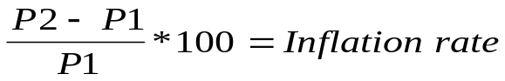
- If prices fall we have deflation, if prices rise we have inflation.
- If the rate of inflation falls, we have disinflation: prices are still rising but at a slower rate.

The History of Inflation
- From 1200 to 1525 prices were very stable, periods of inflation were followed by periods of deflation.

- The first period of sustained inflation ran from 1525 to 1650 and is associated with the gold from the New World being brought back to Spain. It is estimated that the amount of gold increased 5 times, and prices did likewise.

- From 1650 to 1935 prices moved up and down but there were no periods of sustained inflation or deflation. The inflation in the 1920's was matched by a deflation in the 1930's.

- By 1935 most developed countries made the decision to go off the gold standard: there was no check on the money supply and many govts. started printing money. Prices in most countries have risen at least 20 times those in 1935.

- Between 1976 and 1979, most industrialized countries decided not to print money in excess, and prices have been increasing only slowly ever since.

Purchasing Power
- The purchasing power of money measures the real value of money in terms of the goods and services that can be purchased with a given amount of money.
- Inflation reduces the real value of anything with a price fixed in money terms. If people do not anticipate inflation, there will be winners and losers:
- The winners include people who owe money to others: the real value of the amount owed will decline.
- Employers will gain as the real value of the wages they have contracted to pay declines.
- The losers include people on fixed incomes, wage earners who fall behind in real wage terms, and people who lend money.
- Inflation makes export prices more expensive and imports look cheaper so net exports fall and importers will gain while exporters lose.

- To protect against inflation potential losers can anticipate inflation:
- Wages can have an expectational element built in to contracts to protect workers.
- Banks and other people lending money can charge an interest rate high enough to include the anticipated inflation.
- However, people on fixed incomes, particularly the retired are unable to alter their pensions, and this group has been very badly hurt by inflation.

- It is unlikely that inflation will be anticipated properly and different adjustment rates mean that some will gain and some will lose from inflation. One problem area is taxation.
- If there is a capital gain (the value of something purchased has gone up before being sold) some of that gain will be due to inflation and should not be taxed.

- However, most govts. do not make an allowance for inflation in the tax system.

The Interest Rate
- The interest rate is the price paid to borrow money.
- The prime rate of interest is what the banks charge their best business customers and may be thought of as the market interest rate or opportunity cost rate of return.
- The real interest rate gives us the return on the investment in terms of purchasing power and is equal to the nominal interest rate minus inflation:

Real interest rate = nominal interest rate – inflation rate

Supply Shocks
- Inflationary shock: any event that tends to drive the price level upward. Supply shocks arise from:
- Raw materials: increases in price such as the oil shock. Increases in the price of imported raw materials such as oil are usually isolated and not persistent.
- Labour: continued wage cost push is an example of repeated supply shocks.

- The SRAS shifts inward, to the left:
- The price level rises and income falls below the full employment point. This is referred to as stagflation.
- A recessionary gap opens, and pressure mounts for wages and other factor prices to fall.
- SRAS shifts out to the right and there is a return to full employment accompanied by a fall in prices.

- Temporary shocks lead to inflation followed by deflation.
- If the CB responds by increasing the money supply, we say the price shock has been accommodated:
- The increase in the money supply leads to an outward shift of the AD curve.
- This eliminates the recessionary gap, but leads to further inflation.

- Keynesians believe that waiting for cost deflation to restore full employment forces the economy to suffer through an extended slump because wages are sticky down and productivity grows very slowly in a recession.

Wage-cost push inflation:
- Powerful unions may administer repeated shocks by pushing for higher wages:
- Firms pass the wage increases on in the form of higher prices.
- If the CB does not accommodate, the SRAS shifts inward creating a recession.
- Unions would eventually cease pushing wages up in order to maintain jobs.
- Persistent unemployment will erode the power of unions.

Demand Pull Inflation
- A rightward shift in AD can only come about either because of an increase in an autonomous element or an increase in the money supply:
- An inflationary gap opens up and wages and other costs rise leading to a leftward shift of the SRAS.
- The rise in the price level induces changes leading to a movement back along the AD curve to the full employment point. This leads to even more inflation.

- If the CB reacts to the demand shock by increasing the supply of money, it is validating the shock.
- Govt. may not want output to fall, particularly if they face an election.
- Wage increases cause SRAS to shift left, but money supply increases again and AD shifts to the right.
- The price level rises, but output does not fall.

Sticky Wages
- There is a tendency for employers to smooth out the income of employees by paying steady wages and letting profits and layoffs do the adjusting to the shocks in the economy.
- Productivity rises as a worker gains experience but falls off as the worker gets older.
- With wages rising with seniority and layoffs done by seniority, workers and employers are bound to each other.
- Employers know that self policing is the best policy. If workers feel they are unfairly treated they will cut productivity, which is one reason why employers are so reluctant to lower wages.
- It is also a reason why employers tend to pay more than the market wage. They know that working is better than being laid off, and workers will work hard without the need for monitoring if they are paid slightly more than the market wage.

Random Shock Inflation
- These are the supply and demand shocks which often trigger bursts of inflation which must come to an end unless monetary expansion occurs.
- The cost of labour must be related to growth in productivity. If wage increases lead to a rise in unit costs, it must be because wages are rising faster than productivity.

Inflationary gap inflation
- The excess demand for labour associated with an inflationary gap puts upward pressure on wages and the SRAS curve shifts in to the left.
- The excess supply of labour associated with a recessionary gap puts downward pressure on wages.

Entrenched inflation
- Non-accommodated wage push inflation tends to be self limiting.
- If the CB accommodates, both money wages and prices will have risen.
- Workers are no better off so unions try again.
- If the CB accommodates the new supply shock, costs and prices will rise leading to a wage price spiral:
- This can only be halted if the CB stops accommodating the supply shocks.
- The longer the CB waits to do so, the more entrenched will be the expectations.
- Employers expect prices to rise and grant wage increases.
- Workers push for higher wages as they see prices rising.
- Once accommodation stops, stagflation sets in: rising prices combined with rising unemployment.

- If inflation is to continue it must be accompanied by continuing increases in the money supply.
- The general expectation of an x percent inflation creates pressures for wages to rise by x percent and hence for SRAS to shift by x percent.
- In the long run, shifts in SRAS and AD do not effect employment and output, they affect only the price level.
- Thus inflation is a purely monetary phenomenon from the point of view of long run equilibrium.

- If income is held above potential income, the price level will be rising. This can only happen if the CB is accommodating the increase in wages.
- When the SRAS and the AD curves are shifting up at the same speed, the inflationary gap remains unchanged. Eventually people will believe that monetary validation (accommodation) and hence inflation will continue:
- The SRAS will begin to shift up even faster:
- If the CB is told to accommodate in order to hold the level of output constant, it must increase the rate at which the money supply is increased.
- The rate of inflation will start to increase which fuels expectations of increased inflation leading to accelerating or entrenched inflation.

Breaking Entrenched Inflation
- If employers expect 5% inflation, they will agree to wage increases of 5% and raise prices 5%.
- If the CB accommodates, then AD will be rising by 5% per year as well.

- Even if the CB does not accommodate completely, the negative demand effect of a recessionary gap may be rather weak. The demand effect may be swamped by the expectational and random shock effects.
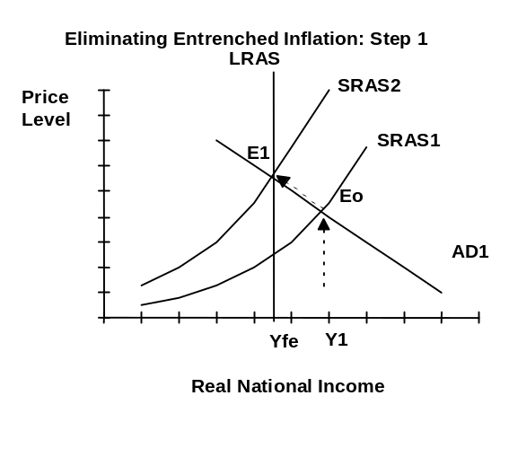
- To break entrenched inflation, the expectation of inflation must be broken:
- Step 1: stop accommodating:
- Tthe rate of monetary expansion has to be slowed to lower the rate at which AD is shifting up.
- The SRAS will keep shifting left at the old rate and will soon eliminate the inflationary gap (from Eo to E1).
- Disinflation results: prices are still rising but at a slower and slower rate.
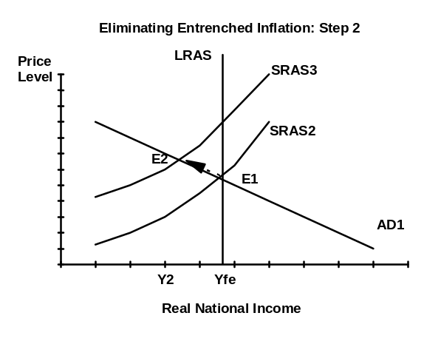

- Step 2: because of inflationary expectations, the SRAS will continue to shift left leading to stagflation:
- Rising unemployment will dampen expectations of inflation and the inflation will halt leaving a large recessionary gap.

- Step 3: return to full employment either:
- By waiting for the SRAS curve to shift to the right (moving to E3a) because productivity is rising faster than wages which lowers prices and increases output
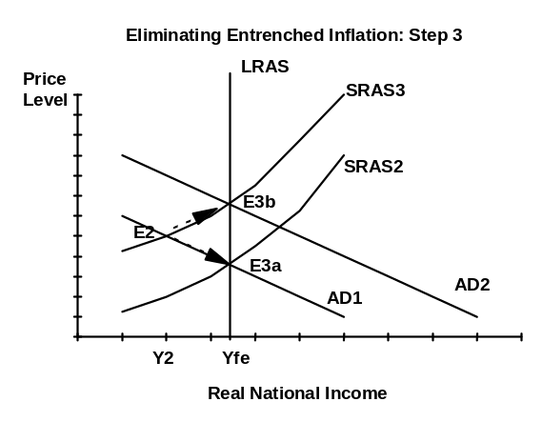
- By using fiscal or monetary policy to shift the AD curve (moving to E3b). The great fear is that this may rekindle inflationary expectations.

- Economists who worry about waiting for wages and prices to fall, fear that the process will take a long time and create a great deal of misery for the unemployed.

3.6 DISTRIBUTION OF INCOME

3.6.1 Direct (Income) Taxes
- Direct taxes are taken from income before there is any expenditure.
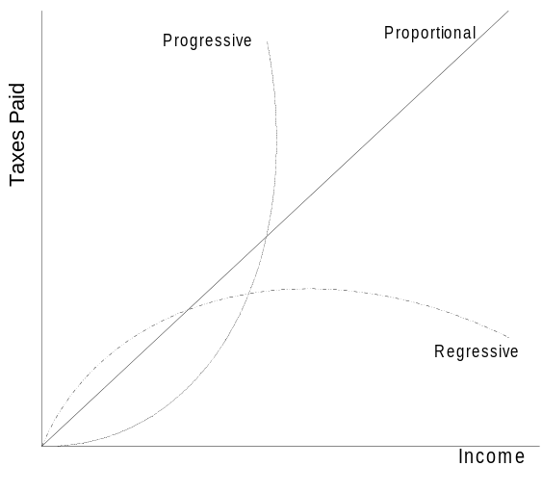
- With personal allowances and higher rates for higher incomes, income taxes can be progressive.
- On the other hand consumption (indirect or expenditure) taxes are generally levied at a constant rate and can therefore be regressive:
- Poor people pay relatively more tax as a proportion of their income on basic necessities than rich people do.
- Several countries have exemptions or lower rates of sales or consumption taxes on things such as food and medicine in order to reduce the regressive nature of such taxes.

3.6.2 Indirect (Expenditure) Taxes
- Indirect taxes are taxes based on expenditure (consumption), and account for 20% of all taxes collected in OECD countries.
- Value added taxes are assessed throughout the production process: each intermediary is able to claim back the tax paid on intermediate goods.
- It is more efficient because it is self policing: each link in the chain will be claiming tax back on the input costs.
- In Europe VAT has now been raised to 20% with little fear of cheating.

- An excise tax is levied on a particular commodity such as cigarettes
- A sales tax is levied on all or most goods which are sold through retail outlets.
- Excise and sales taxes are charged only at the time of sale to the consumer.
- The burden of collecting the tax falls entirely on the seller.
- It can lead to tax cascading: some commodities effectively get taxed more than once; this is related to the double counting problem.
- It is estimated that widespread cheating will occur once the tax exceeds 10%.

- Indirect taxes are less likely to distort behaviour than income taxes:
- High income taxes may lead some to choose leisure over work..
- With indirect taxes some rich people may choose to save and invest.

